CENTER CLUB’S ACTING WORKSHOP

Presents
Charles Dickens’
A Christmas Carol
A Readers Theatre Version
Adapted and Directed by Alan R. Baptista

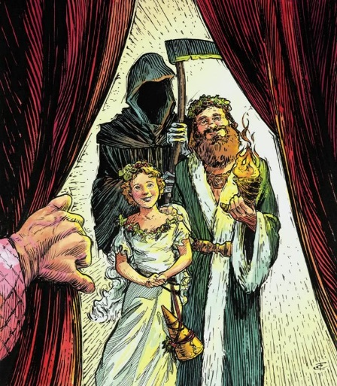

FREE MATINEE FOR CENTER CLUB MEMBERS
THURSDAY, DECEMBER 19 AT 1:00 PM

Thursday and Friday, December 19 and 20, 2019
Doors open at 4:30 PM, Show Begins at 5:00 PM

Center Club
31 Bowker Street
Boston MA 02114

$10.00 Adults * $8.00 Seniors and children 12 years & under
$5.00 for Members of Bay Cove Human Services Programs

Group Rates are Available
For tickets call 617-788-1000 / 617-788-1098 (Spanish) Tickets sold on-site and at the door during performances based on availability

